**Invoice Automation**

Requirements Document [APPROVED]

Version 2.0

Revision History

|  |  |  |  |
| --- | --- | --- | --- |
| **Date** | **Version** | **Description** | **Author** |
| 9/29/22 | 1.0 | Initial Creation | Stephanie Hawkins |
| 10/13/22 | 1.1 | Addition of Keri Caune and Elaine Greene-Yancey as Stakeholders | Stephanie Hawkins |
| 11/3/22 | 1.2 | Change future state SC logo to vertical preferred and one color per Jackie Paulsen | Stephanie Hawkins |
| 11/8/22 | 1.3 | Change to section 3 and addition of question regarding section 5.1 per Elaine Greene-Yancey | Stephanie Hawkins |
| 11/30/22 | 2.0 | Approved Document | Stephanie Hawkins |

Contents

1 Introduction 4

1.1 Purpose 4

1.2 Scope 4

1.3 Contributors 4

1.4 Definitions, Acronyms and Abbreviations 4

2 Overview 5

2.1 Current State 5

2.2 Future State Request 6

3 Understanding the User Environment 6

4 Assessing the Opportunity 7

5 Functional Requirements 7

5.1 General Requirements 7

6 Questions and Issues 8

7 Risks, Assumptions and Related Documentation 8

7.1 Risks 8

7.2 Assumptions 8

7.3 Related Documentation 8

8 Signoff 9

# Introduction

## Purpose

The Accounting and Finance department is looking to automate the invoicing process for Wholesale, reduce the number of emailed invoices sent to the end customer as well as ensure that a cohesive brand identity is portrayed in applicable emailed invoice communication. Automating this process is in alignment with 2022 corporate goal #3 – Simplify the Business, Drive the Core.

## Scope

Currently, the Accounting and Finance department is manually completing marketing fabric memo, swatch, and catalog orders. The department desires to use Dispatch Notes within SYSPRO to reduce paperwork and eliminate inefficiencies in the current process. Additionally, it is desired that the emails and subsequent marketing fabric memo, swatch, and catalog invoices that are provided to customers are consolidated and visually on-brand. The focus of this document is to identify the changes required to support the desired solution as it pertains to marketing fabric memos, swatches, and catalogs. This document does not address the invoice or branding changes that may be required throughout the enterprise.

## Contributors

|  |  |  |
| --- | --- | --- |
| **Name** | **Department** | **Title** |
| Erica Breazeale | Marketing | Director of Channel Marketing |
| Keri Caune | Executive Management | Executive Vice President of Business Development |
| Carla Dooley | Accounting and Finance | Credit and Accounts Receivable Manager |
| Stacy Gentry | Marketing | Director of Brand Marketing |
| Stephanie Hawkins | MIS | Business Analyst |
| Laurie Lewis | Accounting and Finance | Controller |
| Ellen Mims | Accounting and Finance | Invoicing Processor |
| Jackie Paulsen | Executive Management | Chief Marketing Officer |
| Patricia Toney | Accounting and Finance | Accounts Receivable Specialist |
| Elaine Greene-Yancey | Customer Service | Senior Director of Customer Experience |

## Definitions, Acronyms and Abbreviations

|  |  |
| --- | --- |
| **Term** | **Definition** |
| 2Ship | Transportation Management System that reduces shipping expenses by comparing rates and services with all the carriers to find the best price. |
| BAU | Business as usual. |
| CRM | Customer Relationship Management; utilized to manage business relationships with customers. |
| Factor Bank | Third party factoring option for customers. |
| Factor Loan | Factoring receivables; a type of funding method in which a business owner uses unpaid customer invoices as collateral under the agreement to pay back the loan. The business owner still retains legal ownership of the invoices. |
| M-Files | Metadata-driven document management platform. |
| MKT | Market; warehouse name in SYSPRO. |
| NET30 | Refers to a payment period, meaning the customer has a 30-day length of time to pay the total amount of their invoice. |
| Prepaid | Payment in full for an invoice prior to receiving the purchased goods. |
| SQL | Structured Query Language; standard programming language used for relational databases and perform operations on the data in those databases. |
| SYSPRO | ERPsolution designed for manufacturers and distributors. |

# Overview

## Current State

To invoice a fabric sample order, the following manual steps are completed by the Marketing and Accounting and Finance departments:

* Marketing delivers the printed pick ticket and 2Ship tracking label to Accounting and Finance
* Accounting and Finance enter order number, tracking information, shipping date, changes status to 8 and completes the order
* Once the order is invoiced the status automatically changes to 9

Additionally, marketing fabric sample invoice header branding is not consistent from division to division. For instance, a brand logo can be oversized or misaligned on an invoice.

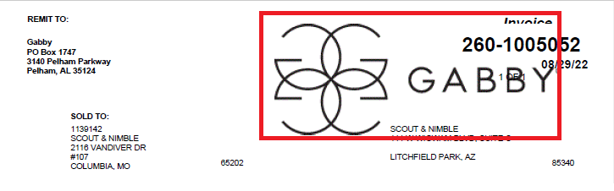

*Current State - Gabby marketing fabric sample invoice header*

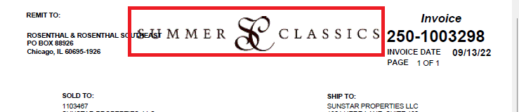

*Current State - Summer Classics marketing fabric sample invoice header*

## Future State Request

To satisfy the business’s needs to invoice fabric sample orders more quickly, the following should occur:

* Fabric sample orders should be accessible for invoicing from the Dispatch Notes Maintenance screen within SYSPRO
* Appropriate shipping information should also be included. This is currently BAU for all other invoices
* Reducing the number of shipping email notifications and invoice email notifications for marketing fabric samples being received by customers
* Develop an SQL exception report that includes specific details on all fabric sample invoice exceptions
* Ensure that company branding, specifically headers, is consistent with current guidelines across all marketing fabric sample invoices, shipping email notifications and invoice email notifications

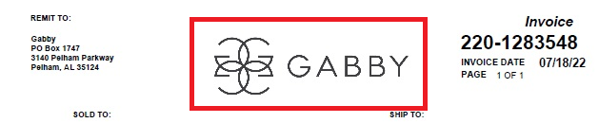

*Future State - Gabby marketing fabric sample invoice header*

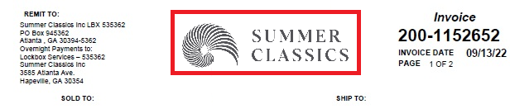

*Future State – Summer Classics marketing fabric sample invoice header*

# Understanding the User Environment

* Who are the users? *Accounting and Finance Department, Credit and Accounts Receivable Manager, Invoicing Processors, Accounts Receivable Specialists*
* Which additional applications do you use that we need to interface with? *SYSPRO, MS Outlook, SQL reports, CRM, and M-Files*
* What are your expectations for usability of the product? *Same as is currently in place for the affected applications.*
* What are your expectations for training time? *Minimal, as the general process and applications are known to the users.*
* What kinds of hard copy and online documentation do you need? *None currently.*

# Assessing the Opportunity

* Who needs this application in your organization? *Accounting and Finance Department, Credit and Accounts Receivable Manager, Invoicing Processors, Accounts Receivable Specialists.*
* How many of these types of users would use the application? *Typically, 1-2 users but can be as many as 7.*
* How would you value a successful solution? *The ability to process fabric sample order invoices through Dispatch Notes, including the inclusion of the shipping information as well as consolidating emails and subsequent invoices received by customers.*

# Functional Requirements

## General Requirements

|  |  |  |  |
| --- | --- | --- | --- |
| **Reference No.** | **Functional Area** | **Functional Requirement Specification** | **Priority** |
| FRS001 | SYSPRO | Allow invoicing of marketing fabric sample orders from Dispatch Notes | H |
| FRS002 | SYSPRO | Include shipping information for invoiced marketing fabric sample orders | H |
| FRS003 | MS Outlook | Reduce the number of marketing fabric sample shipping email and invoice email notifications being received by customers   * *NOTE:* Suggestion is 2-3x per day at certain timeframes (ex. morning, noon, end of day) for both shipping notification and invoice emails. | M |
| FRS004 | Invoices | Update branding of marketing fabric shipping invoices, shipping email notifications and invoice email notifications to reflect new brand guidelines   * *NOTE:*   + While the new brand guidelines are available for review and incorporation, 11/12/22 is the scheduled brand identity Marketing launch for Wholesale   + See Related Documentation for brand guideline links   + Gabby logo should be vertical:preferred and 1 color   + Summer Classics logo should be vertical:preferred orientation and 1 color | M |
| FRS005 | Reports (SQL) | Develop an SQL exception report that includes specific details on all marketing fabric sample invoice exceptions | H |

# Questions and Issues

|  |  |  |
| --- | --- | --- |
| **Requestor** | **Question/Issue** | **Resolution/Answer** |
| Elaine Greene-Yancey | Under section 5.1 (General Requirements) Reference FRS002- Will the tracking information be a clickable link that the customer can use to monitor the shipment? | Patricia/Ellen: We do not believe that the shipping information is a clickable link that the customer can use to monitor the shipment. They usually call or email CS or us and ask for tracking information. |

# Risks, Assumptions and Related Documentation

## Risks

Shipping notification emails and invoice emails are often used as a check and balance for customers. Customers tend to contact Gabriella White if they receive a shipping notification email but do not receive corresponding invoice email. Reducing the number of these types of emails received and sent for marketing fabric sample orders may cause a delay in notifying Gabriella White of missing correspondence.

## Assumptions

That enterprise-wide branding updates and invoice correspondence reduction will be handled through additional Service Desk Request tickets and are not intended to be a part of this document.

## Related Documentation

Service Desk Request Ticket – TBD

[Marketing Swatch Fulfillment Requirements](https://summerclassics.sharepoint.com/:w:/s/ITDepartment/EckLOz9_LBdMpA0NDixXhLIBozSXzaqs-sE1m69mqg6rZg?e=QBtAn9)

[Gabby Brand Guidelines](https://summerclassics.sharepoint.com/:b:/s/BrandMarketing/EYX7W_qCBs1Pl5p0dz2yN_UBAYPgTPMqnV4Q5_qEZ4oqRQ?e=VOkNfy)

[Summer Classics Brand Guidelines](https://summerclassics.sharepoint.com/:b:/s/BrandMarketing/Edg2GOptO8BKoZRcy0E0vTwBJwrKMSyUZ46IdnQ64aak_w?e=Z7oBVW)

# Signoff

|  |  |  |  |  |
| --- | --- | --- | --- | --- |
| **Name** | **Document Role** | **Department** | **Title** | **Approved** |
| Erica Breazeale | Contributor | Marketing | Director of Channel Marketing | Approved (via email) 10/26/22 |
| Keri Caune | Stakeholder | Executive Management | Executive Vice President of Business Development | Approved  11/29/22 |
| Carla Dooley | Stakeholder | Accounting and Finance | Credit and Accounts Receivable Manager | Approved  10/14/2022 |
| Stacy Gentry | Contributor | Marketing | Director of Brand Marketing | Approval no longer required |
| Stephanie Hawkins | Contributor | MIS | Business Analyst | Approved 11/30/22 |
| Laurie Lewis | Stakeholder | Accounting and Finance | Controller | Approved 10/20/2022 |
| Ellen Mims | Stakeholder | Accounting and Finance | Invoicing Processor | Approved  10/19/22 |
| Jackie Paulsen | Contributor | Executive Management | Chief Marketing Officer | Approved 11/28/22 |
| Patricia Toney | Stakeholder | Accounting and Finance | Accounts Receivable Specialist | Approved  10/14/2022 |
| Elaine Greene-Yancey | Stakeholder | Customer Service | Senior Director of Customer Experience | Approved 11/28/2022 |